Watford Velo Sport Hill Climb 2023
Promoted for and on behalf of Cycling Time Trials under its Rules and Regulations
Sunday 24th September 2023 at 09:00

Whiteleaf Hill, Princes Risborough (HHC036)

Event HQ
White Cross Hall, Aylesbury Road, Princes Risborough, HP27 0JT
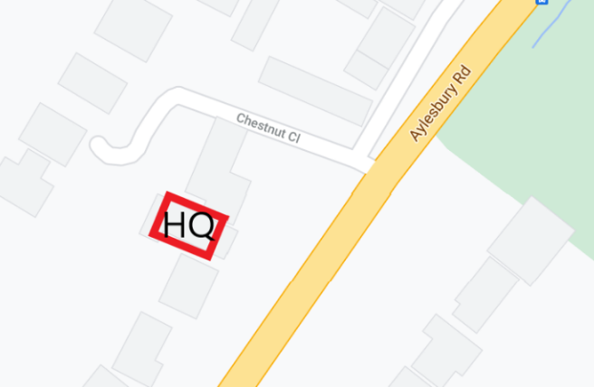
Sign On
HQ Opens 08:00
First Rider 09:01
Last Rider 09:26
Prizes 10:00
HQ Closes 11:00

Time Keepers
Christina Gustafson & Tom Mead-Herbert (assistant)

Event Manager
Thomas Mead-Herbert – 07766 022292
Event/Club Secretary
Robert Broderick – 07595 746192

Prizes
Prize List | 1st | 2nd | 3rd
Overall Men | £ 30.00 | £ 20.00 | £ 10.00
Overall Women | £ 30.00 | £ 20.00 | £ 10.00
Veteran (40+) | £ 30.00 | £ 20.00 | £ 10.00

Course Details
https://www.strava.com/segments/29843829

START on Peters Lane approx. 370ft from junction of Aylesbury Road and Peters Lane opposite telegraph pole in line with triangular ‘School’ sign continue on Peters Lane for 0.8miles until FINISH at top of Whiteleaf Hill by end of entranceway by water tower.

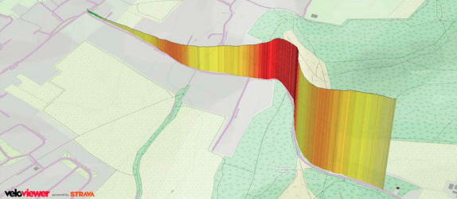

Safety Instructions and Regulations
• Helmets All competitors must wear a properly affixed helmet which must be of hard/soft shell construction. Helmets should conform to a recognised Standard such as SNELL B95, ANSI Z90.4, AUS/NZS 2063:96, DIN 33-954, CPSC or EN 1078.
• London West DC strongly recommend that riders do not wear black or dark clothing during any event held on the public road, to improve rider safety by making riders far more visible on the roads.
• Lights CTT Regulation 14 requires that “No competitor shall be permitted to start either a Type A or Type B event unless such competitor has affixed to the rear of their machine a working front white light AND rear red light, either flashing or constant, that is illuminated and in a position that is clearly visible to other road users”.
• Warming up Competitors are requested not to warm up on the course after the first rider has started.
• No Vehicles, except those of the Timekeepers’ and Event Officials, shall be parked in the vicinity of the start and finish areas
• Competitors must not use ANY audio equipment except prescribed hearing aids. A competitor in breach of this regulation shall be disqualified. Competitors must not use a mobile phone while mounted on their machines.
• No time may be recorded if number is not correctly positioned
• Official Observers will be stationed around the course
• Signing Out Please note competitors must return to the event HQ either during the event or within a reasonable time after the last rider has finished the event and must return their race number and sign the official signing out sheet. A rider who fails to so sign the official signing out sheet shall be recorded as DNF.
• PLEASE KEEP NOISE TO A MINIMUM FOR RESIDENTS AND RESPECT PARKING RESTRICTIONS. DO NOT park at HQ or block the road.

Thank you for your co-operation.

